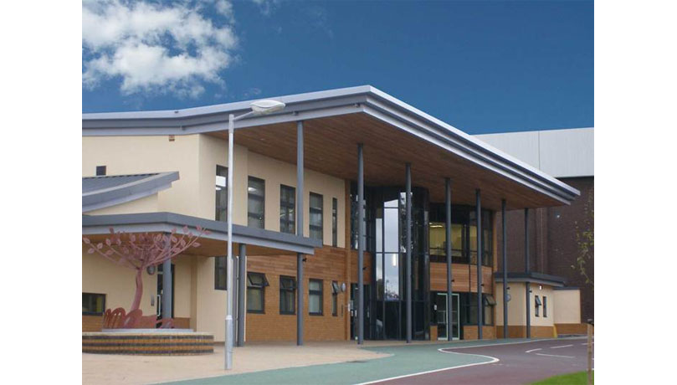



Directed Time Overview

September 2025

Date of Next Review: September 2026

Person Responsible: Miss Tina Partridge (Headteacher)

Old Park School

Directed Time – Teachers

The amount of time to be worked and the days upon which it will be worked by a teacher is the subject of directions made under the School Teachers Pay and Conditions Act and set out in the document.

A teacher employed full-time, other than in the circumstances described in the current School Teachers’ Pay and Conditions Document, shall be available for work for 195 days in any school year, of which 190 days shall be days on which you may be required to teach pupils in addition to carrying out other duties; and those 195 days shall be specified by your employer or, if the employer so directs, by the Headteacher.

A teacher will be available to perform such duties at such times and such places as specified by the Headteacher for 1265 hours in any school year, those hours to be allocated reasonably throughout those days in the school year on which you are required to be available for work.

Time spent in travelling to and from the place of work shall not count against the 1265 hours referred to.

Educational visits as approved and directed by the Headteacher involving a teachers working day being longer than that of the normal school day, will be classed as part of the 1265 hours and taken from the contingency hours specified.

It is not practical for the time taken by school journeys extending overnight or weekends (including residential visits) to be accommodated within the 1265 hours of directed time available. Therefore, these activities should only take place where it is established that they are voluntary and on the initiative of the teachers concerned and not the subject of direction.

It is for the LA to determine the school year and term dates and this is done following consultation with interested parties.

It is for the Headteacher to assign the 1265 hours, subject to guidance from the LA. Teachers engaged for less than full time should be treated pro rata. The advice is to seek to ensure that part time staff are treated comparably with full timers in the division of their teaching and non-contact time.

The current School Teachers’ Pay and Conditions Document (para 62.6) states that in addition to the directed 1265 hours, teachers should work such additional hours as may be needed to enable them to discharge effectively their professional duties, including, in particular planning and preparing courses and lessons; and assessing, monitoring, recording and reporting on the learning needs, progress and achievements of assigned pupils, the marking of pupils’ work, the writing of reports on pupils and the preparation of lessons, teaching material and teaching programmes.

The amount of time required for this purpose beyond the 1265 hours referred to and the times outside the 1265 specified hours at which duties shall be performed, shall not be defined by the employer but shall depend upon the work needed to discharge such duties.

PPA time must be provided in units of not less than half an hour during the school’s timetabled teaching week and must amount to not less than 10% of the teacher’s timetabled teaching time. A teacher must not be required to carry out any other duties during the teacher’s PPA time.

PPA entitlement is 10% of teaching time; therefore 2.5 hours for full time teachers; 2 hours for 4 days per week; 1.5 hours for 3 days per week.

If PPA time is missed due to school organisational demands, all efforts will be made to ensure no teacher has less than 10% PPA time.

Additional PPA time is currently being trialed for all teachers and HLTAs during the current academic year, and is detailed later in this document.

Supporting Documentation

<https://www.gov.uk/government/publications/school-teachers-pay-and-conditions>

<https://assets.publishing.service.gov.uk/government/uploads/system/uploads/attachment_data/file/665522/Teachers_standard_information.pdf>

<https://www.rbkc.gov.uk/pdf/Post%20threshold%20standards.pdf>

Old Park School Teacher Directed Time Calculation

|  |  |  |
| --- | --- | --- |
| Activity | Time Directed | Total |
| School Day | 8.40-3.25pm  (less 30 minutes lunch)  6 hours 15 minutes x 190 days | 1187.5 hours |
| Inset Days | 8.45-3.00pm  (less 30 minutes lunch)  5 hours 45 minutes x 5 days | 28 hours 45 minutes |
| Monday Morning Briefing | 8.30-8.40am  10 minutes x 39 weeks | 6.5 hours |
| CPD Staff Meeting | 3.25-4.25pm  (Tuesday Primary, Wednesday Secondary)  1-hour x 39 weeks | 35 hours 45 minutes |
| Parents Evening | 4.25-6.05pm  (Autumn term)  4.25-6.00pm  (Spring term) | 3 hours 15  mins |
|  | Total | 1265 hours |

* School day includes 2.5 **h**ours per week PPA time entitlement**.**
* All teachers receive an additional 1.5 hours per week release time from teaching. This incorporates 1 hour additional discretionary PPA time and 30 mins directed time each week. The directed time should be used to focus on additional tasks relating to the SEND needs of their learners, subject co-ordinator tasks or performance management review.

Directed Time – Higher Level Teaching Assistants (HLTA’s) 37-hour contract

HLTA’s are contracted to plan, deliver and assess up to 50% of their worked days. For HLTA’s with 37-hour contracts this equates to 17.25 hours per week (37 hours less 30 mins lunch break each day, divided by 2). Where HLTA’s work part time this requirement is calculated on a pro-rota basis.

In addition, HLTA’s can be directed to deliver small group teaching and annotation/assessment, where the lesson has been planned by the teacher. This is in line with the expectations of Level 3 Teaching Assistants.

The additional 4.5hours hours contracted time per week must be spent in school. Individuals have some flexibility around when these hours are completed. However, HLTA’s must submit their preferred working pattern in advance to the Headteacher for approval at the start of each academic year. Once approved, this will only be changed in exceptional circumstances.

HLTA’s are given Planning, Preparation and Assessment time which currently equates to 1hour 10 minutes per week. This is being trialed during the school day for the remainder of this academic year.

All HLTA’s are expected to attend one weekly CPD meeting lasting up to 1 hour. This is included within the 37-hour contracted time. HLTAs are not currently contracted to work beyond 4.25pm during parent’s evenings.

The remaining additional hours worked outside of the school day, are directed in line with school development priorities and areas of responsibility. These are overseen by the Deputy Headteacher.